**CODING CHALLENGE (CAR RENTAL SYSTEM)**

1. Update the daily rate for a Mercedes car to 68.write an sql query.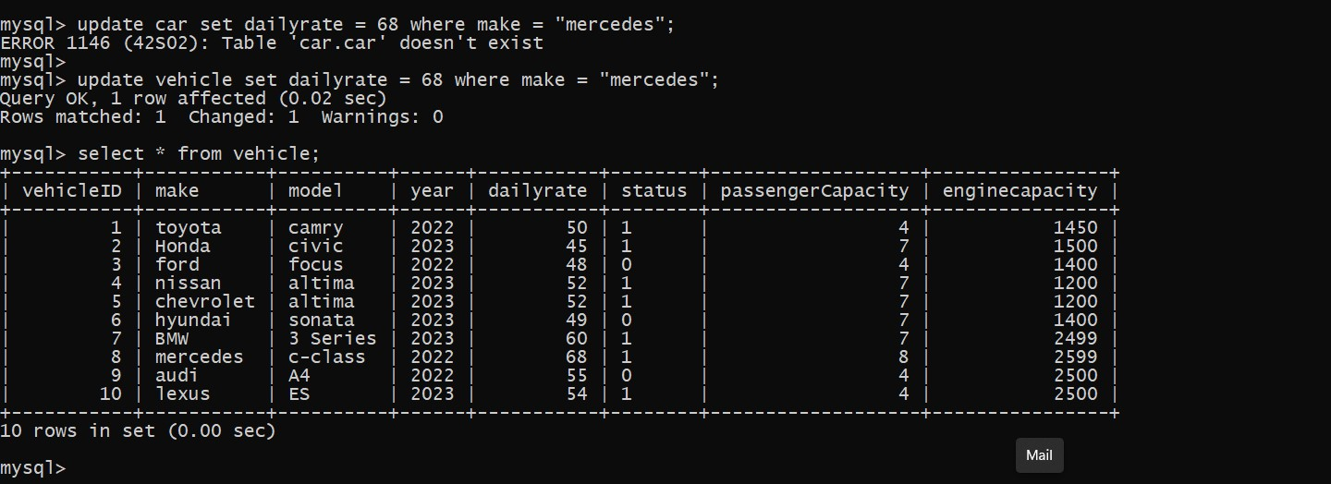
2. Delete a specific customer and all associated lease and payments

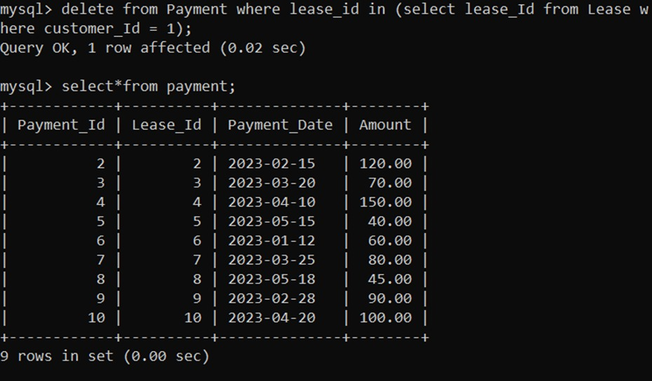

3)Rename the “paymentdate” column to “transactiondate” in the payment table.

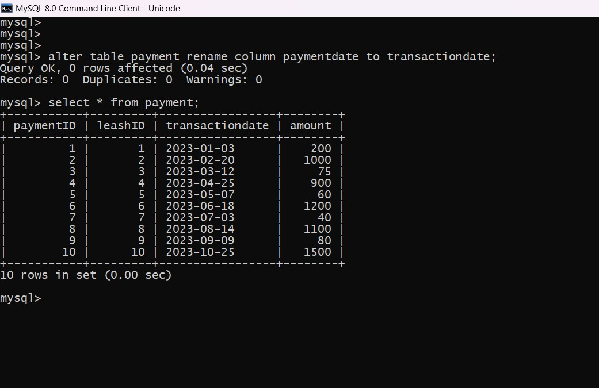

4)find a specific customer by email.

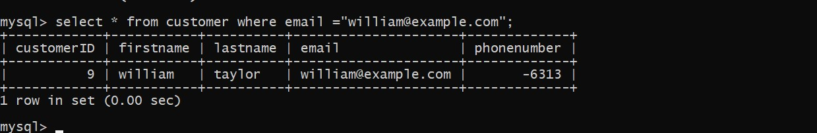

5)Get active lease for a specific customer

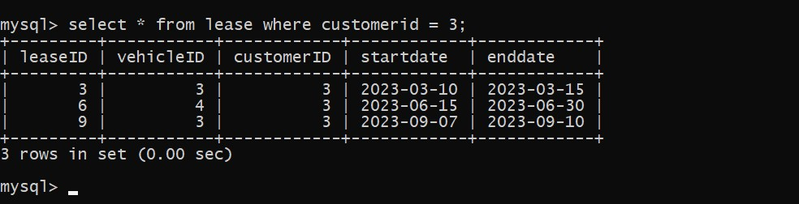

6) find all the payments made by a customer with a specific amount.

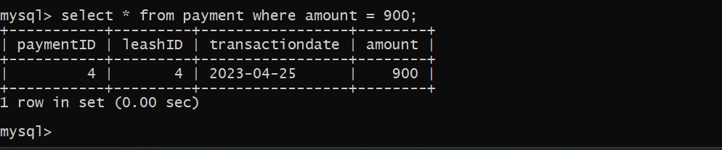

7)calculate the average daily rate of all available cars.

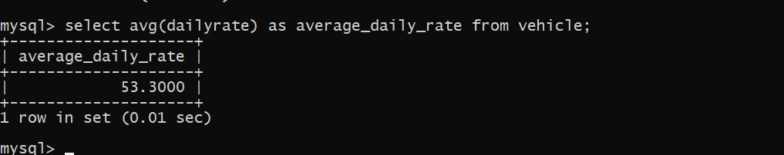

8)Find details of the most recent lease.

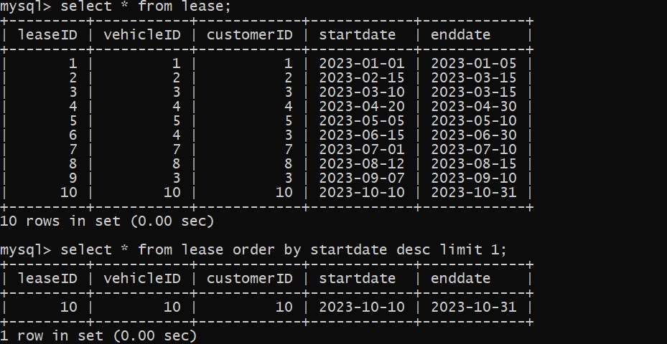

9). Find the car with the highest daily rate

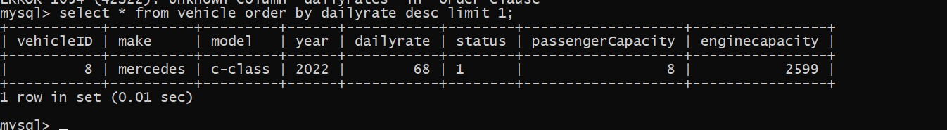

10) Retrieve all cars leased by a specific customer.

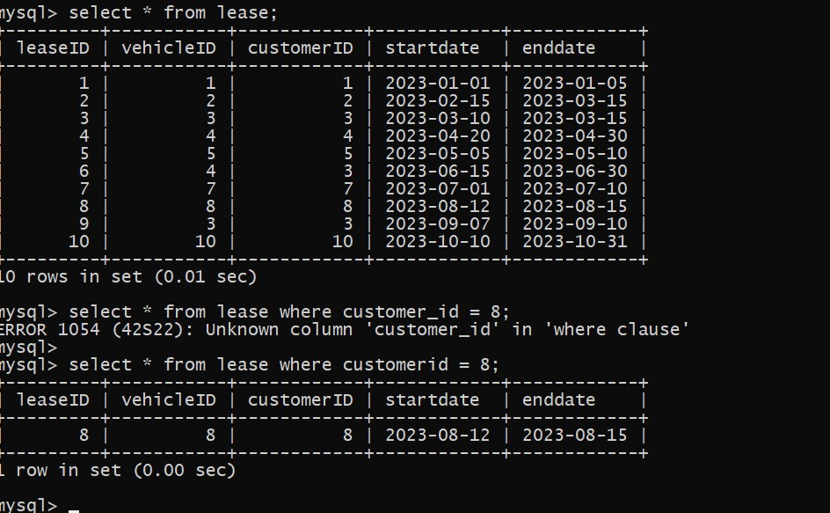

11)list all the payments made in year 2023.

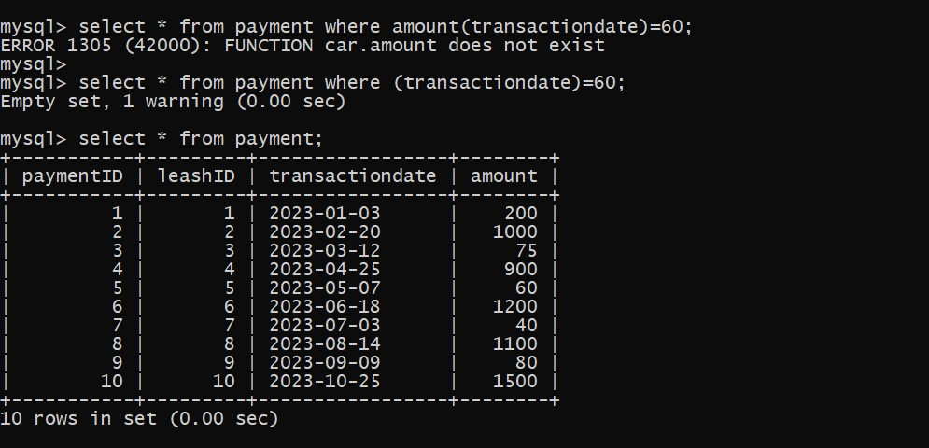

12. Retrieve customers who have not made any payments.

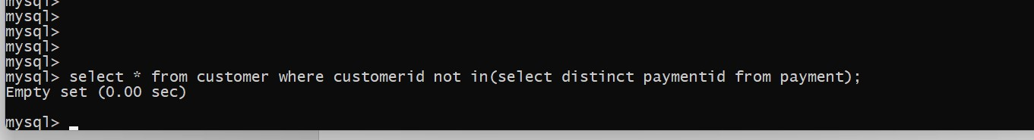

13. Retrieve car details and their total payments.

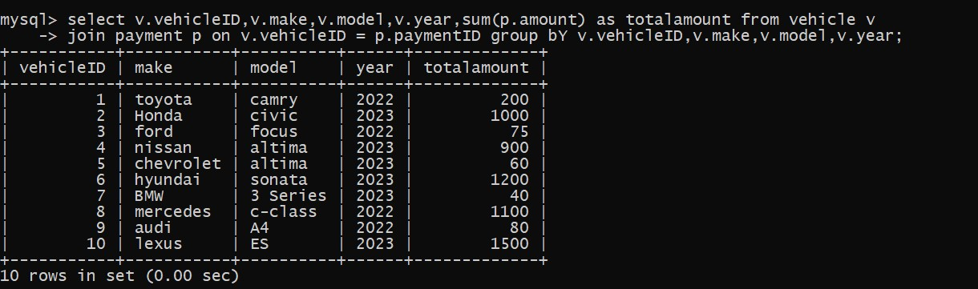

14. Calculate Total Payments for Each Customer

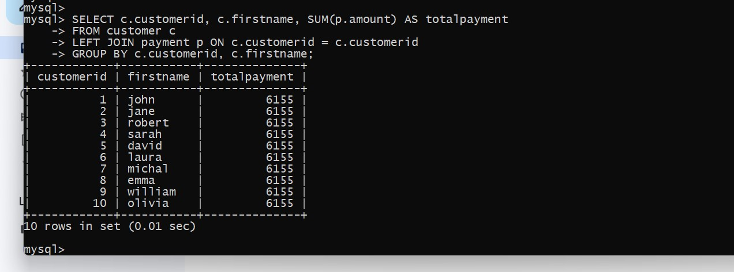

15. List Car Details for Each Lease

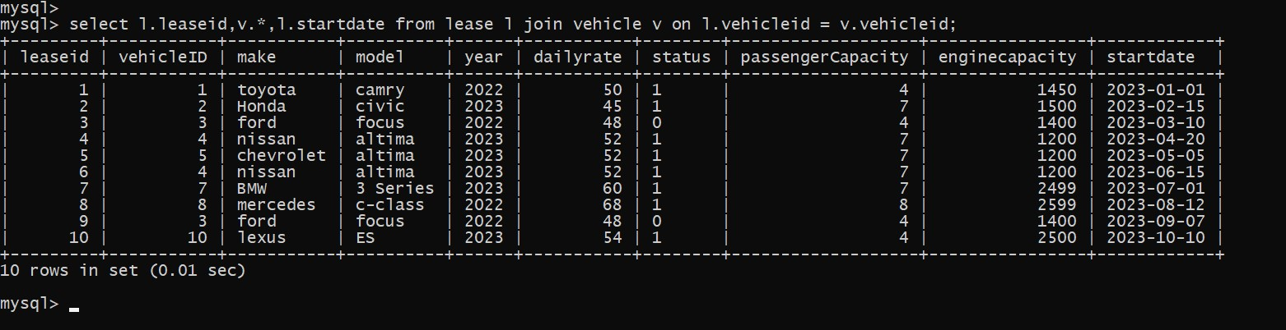

16. Retrieve Details of Active Leases with Customer and Car Information.



17. Find the customer who has spend most on lease.

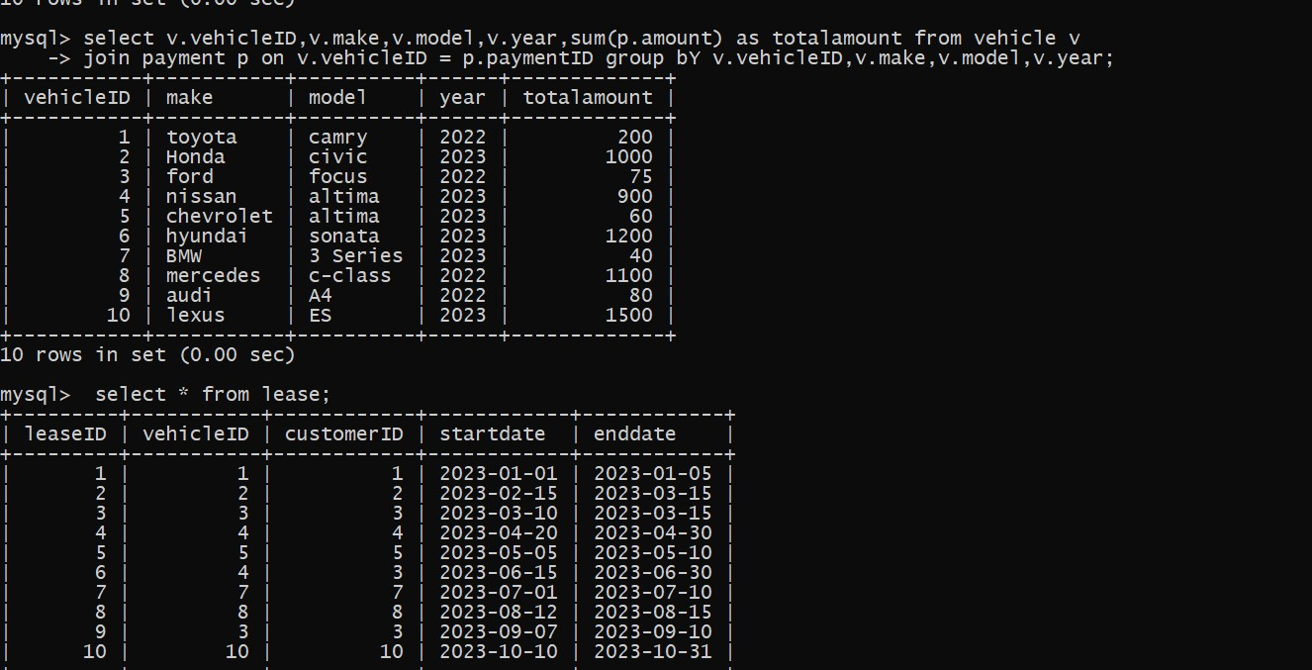

18. List All Cars with Their Current Lease Information

